WEEK – 1

FIRST LLM API CALL USING GEMINI

Step-1: create the folder
Document-GenAI-Lab experiments- week – 1
Step-2:VS code
Open the folder in vs code
Step-3:check python
Type - py –version & py -0p
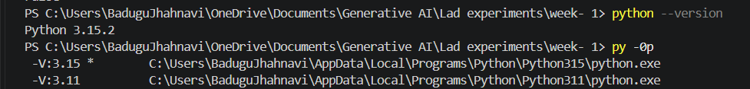
Step-4: create the environment
Type: python -m venv .venv and wait
Step – 5: Activate the environment
Type: .\.venv\Scripts\Activate.ps1

Step-6: Install OpenAI
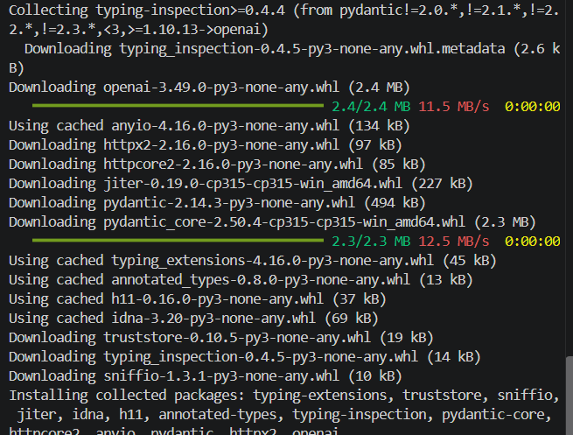
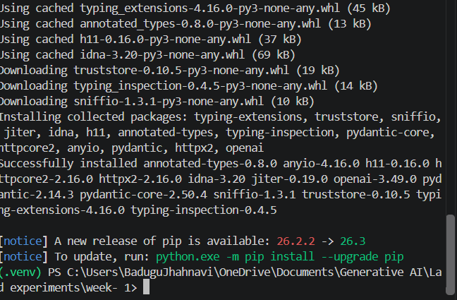

Step- 7: Install python-dotenv

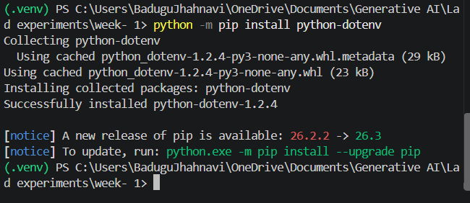
Step-8: verification of open AI
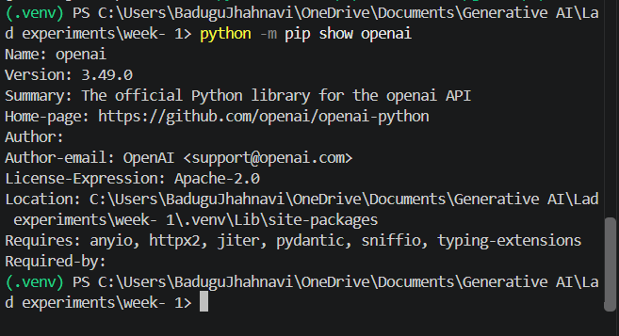

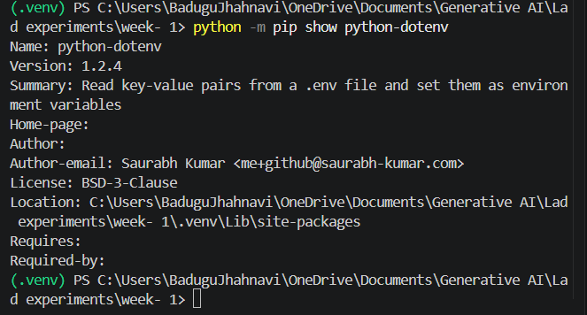

Step-9: create main.py file
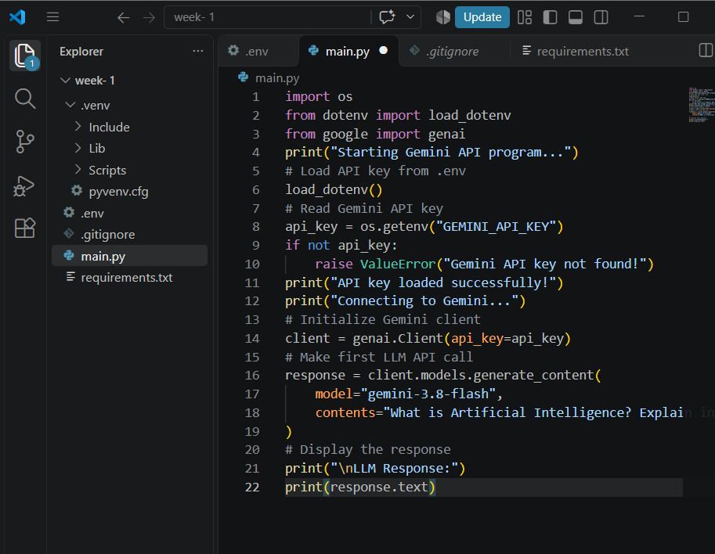

Step – 10: create a .evn file
Paste the gemini key in the file
Step-11:create a file
File name requirements.txt
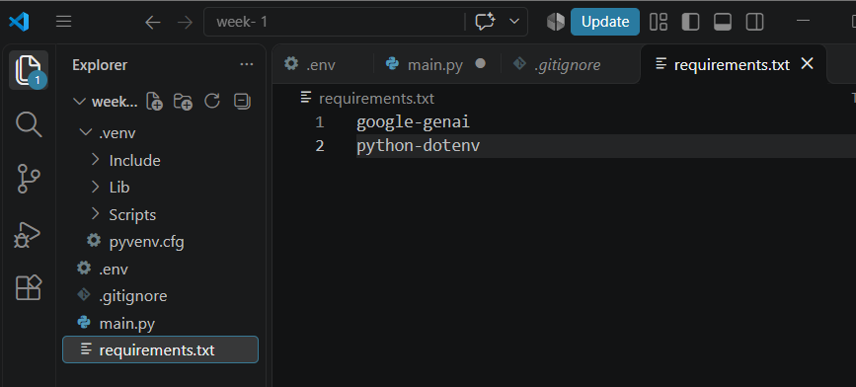

Step – 12: create a file with name .gitignore

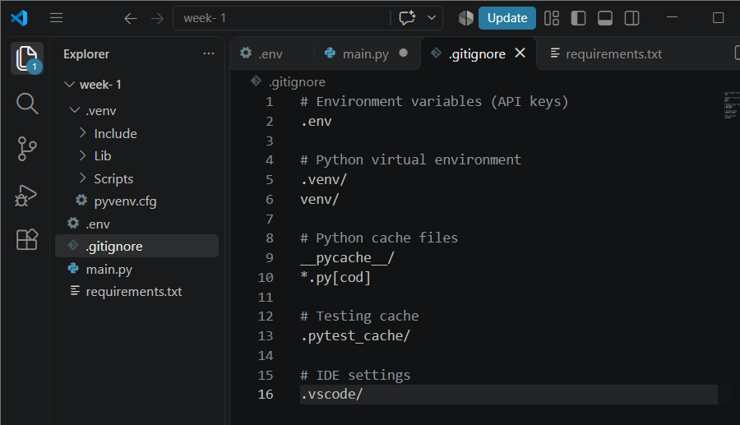

Step – 13: Enter command python -u main.py to get the output



